Where information for each report is displayed row by row in a table:

# writereports.php

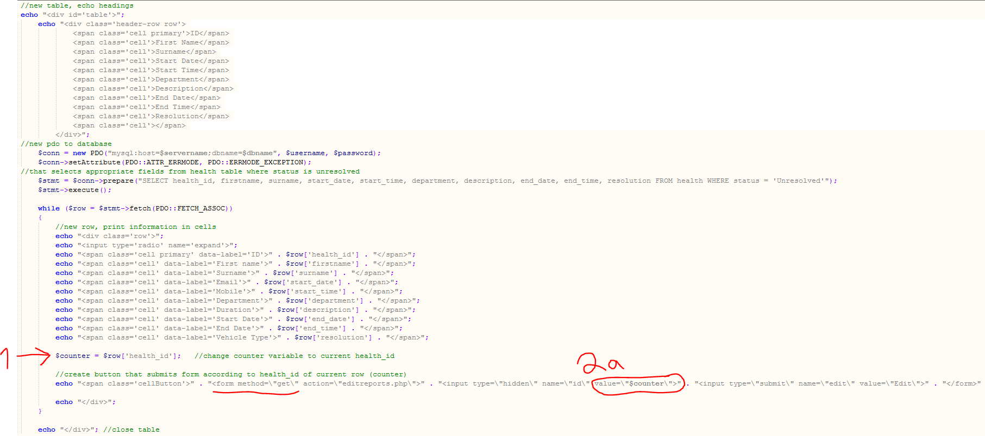

Step 1:

For each report row, save its id in a $counter variable

Step 2a:

When that report is selected, submit that hidden value in a PHP get form, and…

# writereports.php (cont.)

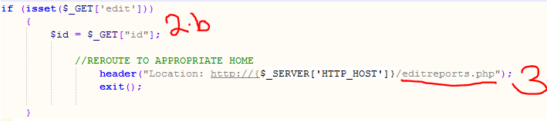

Step 2b:

…Save the id in a $_GET variable.

Step 3:

Redirect to new page with editable input fields

(P.T.O.)

# editreports.php

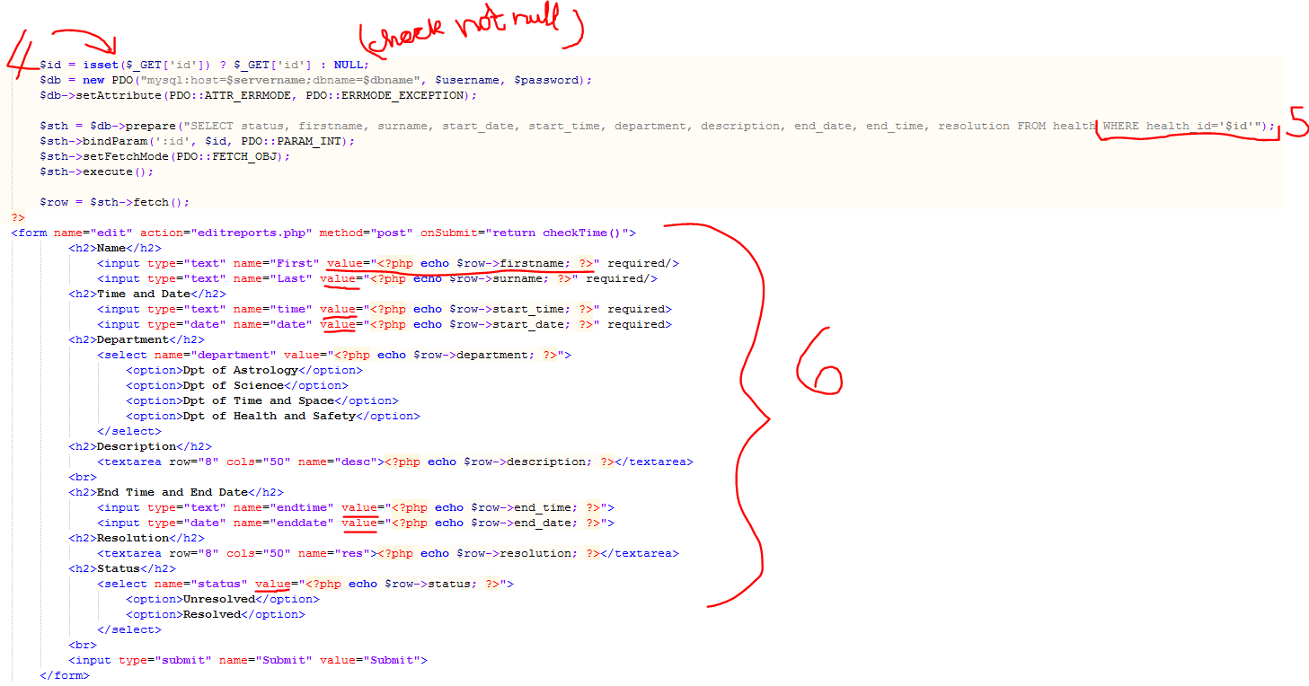

Step 4:

Retrieve the report id

Step 5:

Access the rest of the information from that report using an SQL query specifying the report id

Step 6:

Set the values of the input fields to the data returned by the SQL query

# editreports.php (cont.)

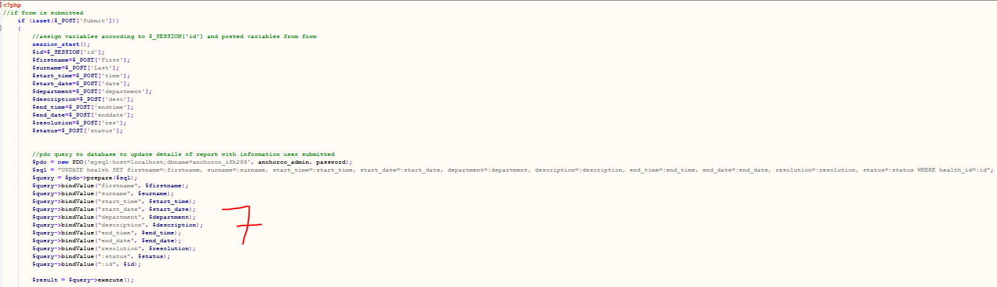

Step 7:

Update the details of the report upon page submission according to the new input field values.